Review Information
Document Prepared By: | Delya Babenko
Signature/Date | 05/21/2007
CR Id | CR123456
Business Process Owner | Jackie Videlka
Functional Area | SD
Description | MedNet Edits
Requirement Type | Interface | Conversion | Enhancement | Report | Form

Change Control
Doc. Version No. | Revision. Date | Changed by | Change Summary
1.0 | 05/19/2007 | Delya Babenko

Cross-Functional Dependencies
Process Area | Impacted | Comments | Initial
SD/SCM | None | With this enhancements, no impact to any processes. | D.Babenko

Open issues
Issue No | Issue Date | Issue Title / Description | Priority | Resolved Date | Any Other Comments

General Report Information
N/A

Please select from the following:
New Report: List any Standard Business Content that exists for this report.
Title: _________________________________________________
Technical Name: ________________________________________
Current Hospira Report: Are these requirements based on an existing report?
Title: _________________________________________________
Technical Name: ________________________________________

Distribution Requirements
N/A

Recipient ID / Name | Send to Location | Number of Copies | Distribution Requirements

HLD Check list

Description | Yes |  | No
Functional Requirements check list

2.1 – Requirements Description | Y
2.2 – Business Functionality | Y
2.3 – General Requirements | Y
- Validation Criteria /Error Handling
- Dependencies
- Triggering Point
- Risks
- Language Support
- Authorization / Security
- Frequency/ Data Volume

2.4 – Inbound/Outbound/Conversion/Interfaces | N/A
- Interface/Conversion type
LSMW
BDC - Recording
BAPI (Business Object, Method, Message Type, Basic Type)
IDOC (Message type, Basic Type, Enhancement
- Validation Criteria for input records
- Data Owner/Archiving/Data Retention
2.5 – ABAP/SAP Form Report Layout | N/A
- Detailed Report / Form Layout
- Report / Form Properties
- Report Medium

2.6 – Additional Requirements to BW | N/A
- Request Type
- New / Existing Info provider

2.7-- Test scenarios and test data | Y

Sign-Off / Final Approval
 | Name | Signature | Date
Functional Team Leader
Project Management
Technical Team Leader

Functional Requirements

Requirements Description (functional Narrative of business logic & Rules)
Hospitals (Hospira customers) can procure MedNet pumps and devices directly from Hospira (MedNet Direct) or through a financial arrangement with 3rd party payer like CitiCapital.

Business Functionality
MedNet and CitiCapital transactions will impact 3 Types of orders in SAP:
ZMTS - MedNet - 3rd Party
ZNTS - Non MedNet - 3rd Party
ZMDS - MedNet DIRECT Sale
MedNet pumps and other equipment shipped to customers but paid by 3rd party payer (for example Citi Capital) shall have CitiCapital as Bill-to and Payer in the sales documents. These sales documents will have Purchase order types entered as “ZMTS - MedNet - 3rd Party” or “ZNTS - Non MedNet - 3rd Party”. When these pumps are paid directly by the customer, PO type “ZMDS - MedNet DIRECT Sale” is used at the time of order entry.

General Requirements

Data Flow & Detailed Processing Logic (Overview Diagram)

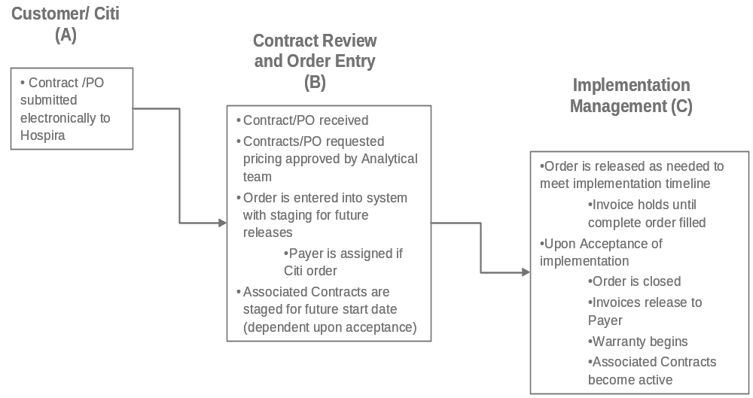
Warning message to be issued based on the new Material group 6 = MN, which identifies the material as MedNet capable and Bill-to and Payer are not 3rd party. This warning message shall be issued one time though the checking is done for each line. Depending up on the PO type in the sales order, the following rules are implemented in the system during the order processing:
PO Type: ZMTS - MedNet - 3rd Party
Bill-to and Payer should be 3rd Party (for example ‘Citi Capital’). The value shall be validated/read from ZMAPRULE table. Delivery block is applied through ZCOM if the Bill-to and Payer are not as in ZMAPRULE table.
Plan type ZT should be automatically populated if the product is a serialized product (MARC-SERNP = Z003). This in done through ZBAFI.
Plan type ZT is not required to be populated by the system since it should be populated only for CITI Capital customer and not for any other thitd party customers. User will enter the value manually.
Billing block should be applied to the order during order creation. This in done through ZBAFI.
PO Type: ZMDS - MedNet DIRECT Sale
Bill-to and Payer should NOT be 3rd Party like ‘Citi Capital’. The value shall be validated/read from ZMAPRULE table. Delivery block is applied through ZCOM if the Bill-to or Payer is ‘Citi Capital’.
Plan type is not applied automatically. Delivery block should be applied through ZCOM edit, if the plan type is populated manually with ZT.
No validation is required because the value is entered manually by the user.
Billing block should be applied to the order during order creation. This in done through ZBAFI.
Note: If PO type is neither ZMTS - MedNet - 3rd Party nor ZNTS - Non MedNet - 3rd party, Bill-to or Payer should NOT be 3rd Party like Citi Capital.

SAP Program/ Function Modules/ Custom Program
MV45AFZZ

Screen Design/Selection screen
N/A

Validation Criteria / Error Handling

Dependencies

Process Dependencies
N/A

Functional Dependencies
Purchase order type should be entered as either ZMTS or ZNTS for the user exit to change/populate the structure passed to VERTEX with Bill-to/Payer customer. VERTEX should be maintained with third party payer (for example CitiCapital) as tax exempt. One new Plan type “ZT - Outright Sale 3rd party payer” to be configured. 2 new billing blocks to be configured, one for Customer Direct MedNet Sale (ZD) and the other one for MedNet 3rd Party Sales (ZT).

Data Dependencies
Material group 6 (MN) to be configured in material master to identify MedNet and Non-MedNet materials. New movement type to be determined based on PO types to ensure that the postings to COGS happens only after sales revenue is recognized.

Job Dependencies
N/A

Risks
None

SAP Transaction / Custom Transaction
VA01/VA02/VA03

Language Translation Requirements
N/A

SAP Security
None

Frequency / Data Volume/Performance
N/A

Trouble Shooting /Restart/Recovery Strategy
Standard SAP

Inbound/Outbound/Conversion/Interfaces

Inputs / Outputs
N/A

Table effected
N/A

SAP Data Clean up
N/A

Data Owner/Archiving/Data Retention
Jackie Videlka - Customer Service Group

ABAP/SAP Form Report Layout
Not applicable

Report/Form Name (Applicable only for SAP Scripts / SMART Forms)

Report/Form Layout Overview (Standards)

Report/Form Output Requirements/Properties
{Examples of report properties are shown below. You may include more as needed}
Report Properties | Property Description
Report type (i.e. Tabular, bar graph, pie chart, combined …)
Report composition: (i.e. list, comparison …)
Alignment (current or historical)
Time Frame needed (Current and Prior year, 12 rolling months …)
Decimal places (0.0, 0.00 …)
Percentages (Format) (0.0%, 0.00% …)
Unit of measure required (lb., inches …)
Scaling (i.e. figures shown in thousands …)
Currency type required ($, CAN$ …)
Alerts needed (Only send report if sales < $10,000 …)
Variant (needed to run report in source system)

Report Medium
how do you want users to see/access your report.

On-line (Source system) Internet/Intranet Hard copy E-mail Text File Excel File
Other:

Additional Requirements to BW
Not applicable

Request Type

Check all that are applicable
Creation of New Info Provider | Change to Existing Info Provider | Data Refresh of Info Provider | Create New Query

Creation of New Info Provider

Source System | SAP Functional Area | SAP Tables | SAP Field | Other Source Location / Comments

Change of Existing Info Provider

Source System | SAP Functional Area | SAP Tables | SAP Field | BW Info Object | Change Required

Data Refresh of Info Provider

Please select from the following:
Historic Data Refresh (All Data): Info Provider Technical Name:
Reason for Data Refresh:
Historic Data Refresh (Range of Dates): Info Provider Technical Name:
Date Range for Data Refresh:
Reason for Data Refresh:

Create New Query
N/A

References

Hospira HLD

SD-OM-E-REQ1404 MedNet Edits HLD

Original Functional Contacts
Rupendra Murkonda

Original Technical Contacts
Delya Babenko

Other Documents and Links
N/A

*** End of document ***

